- Task to create a bash script to check if a directory is available or not.
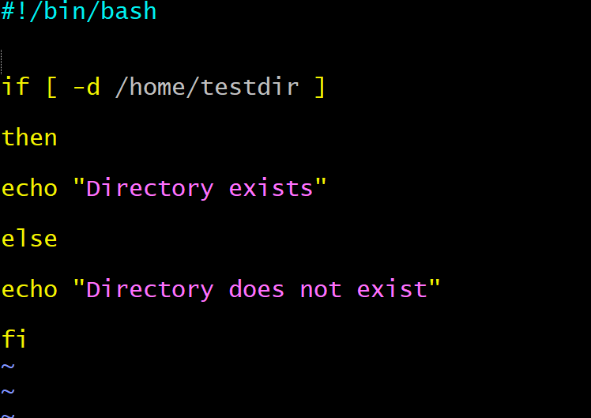
Output:
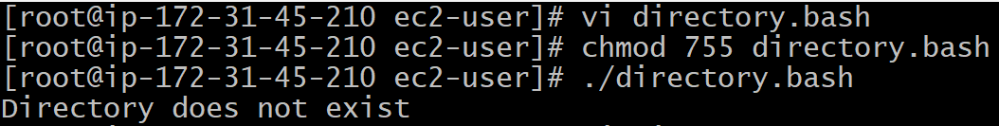
Now I have changed directory exits
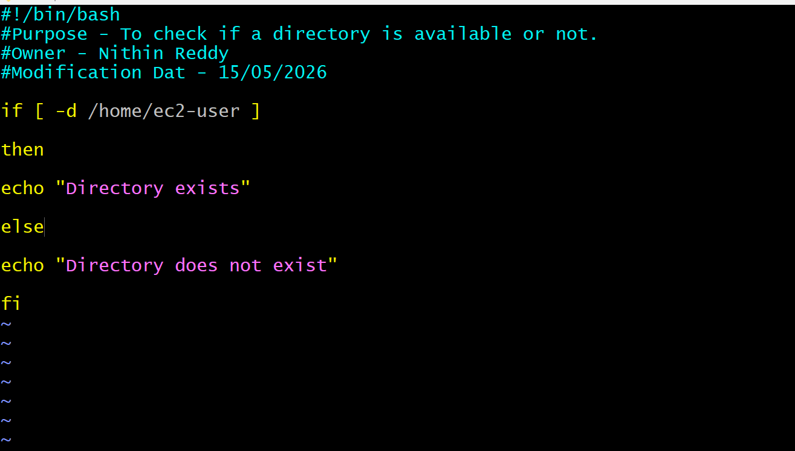
Output
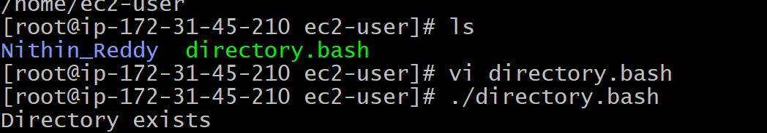
- Create a bash script to create multiple files.
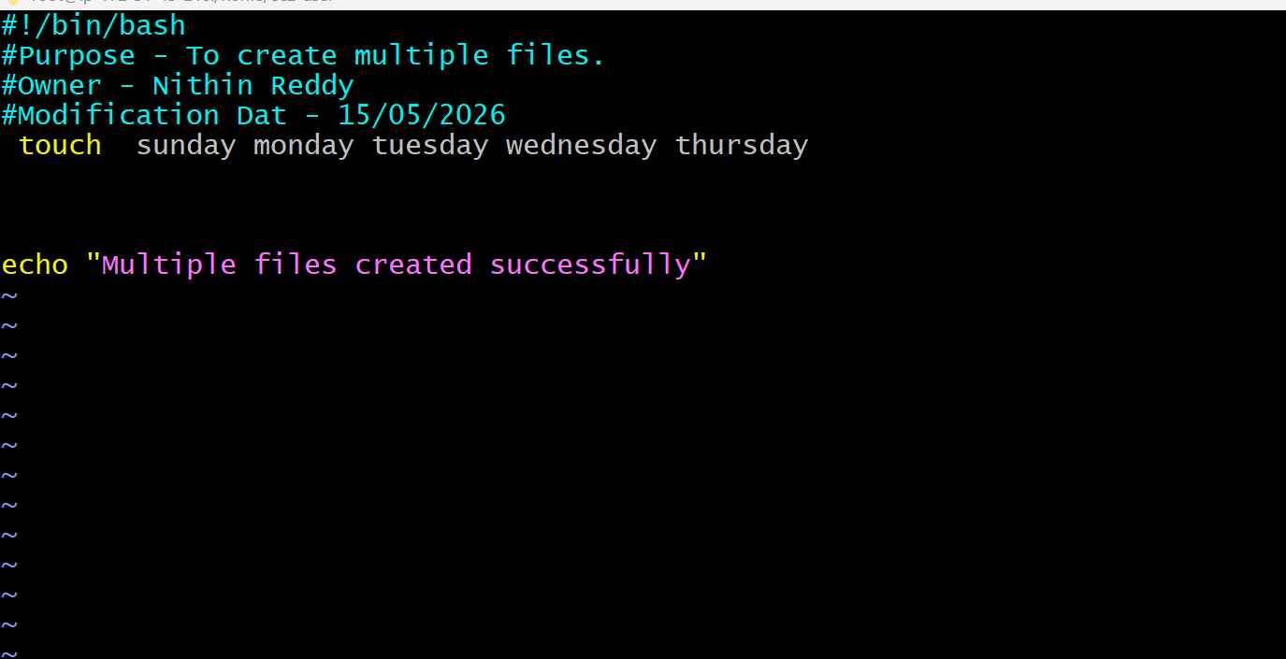
Output :
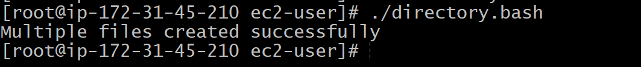

- Create a bash script to take a backup of a directory.
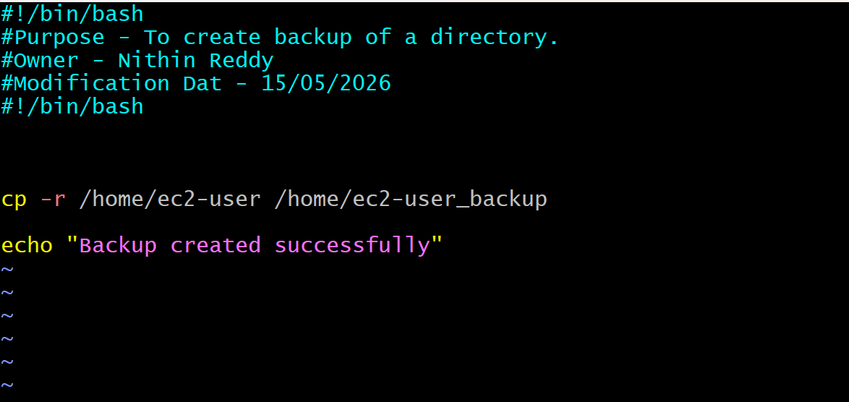
Output
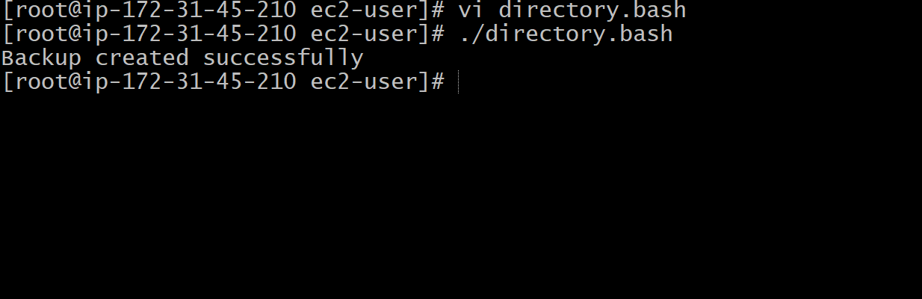

- Create a bash script to install Nginx on an EC2 server.
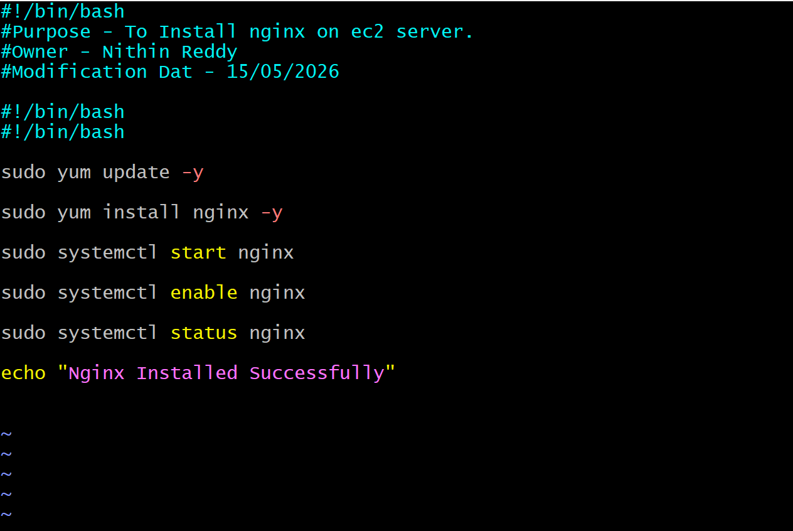
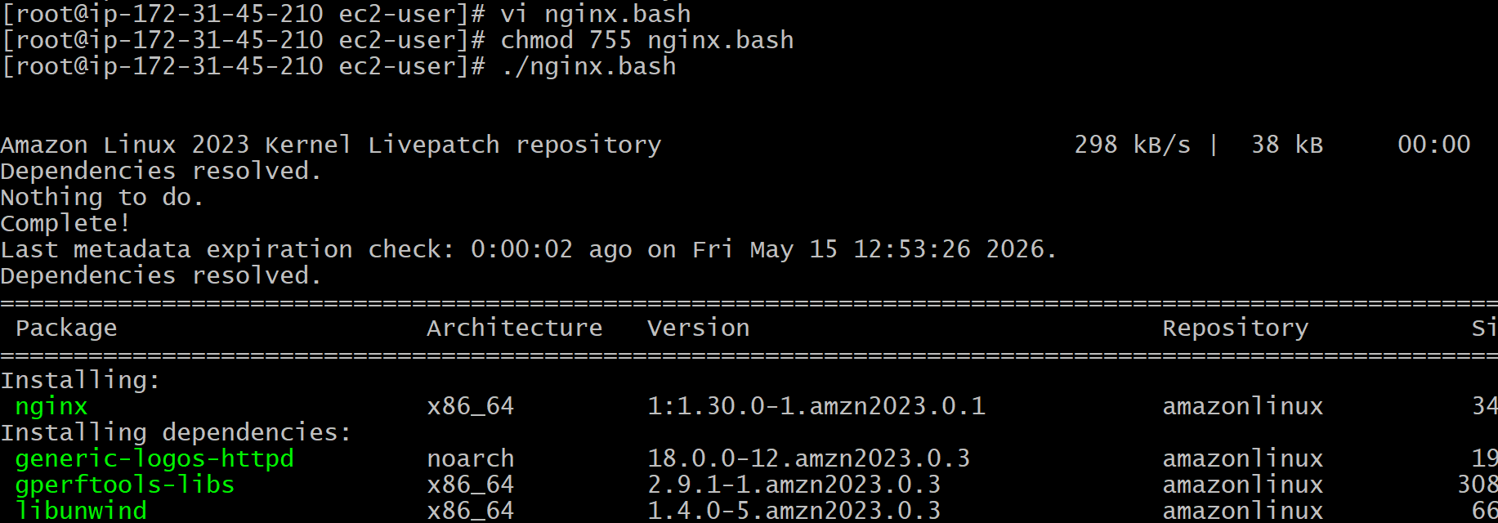
Nginx Running successfully
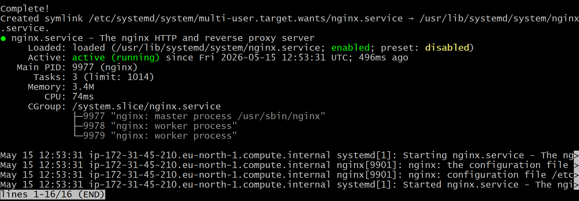
Output:
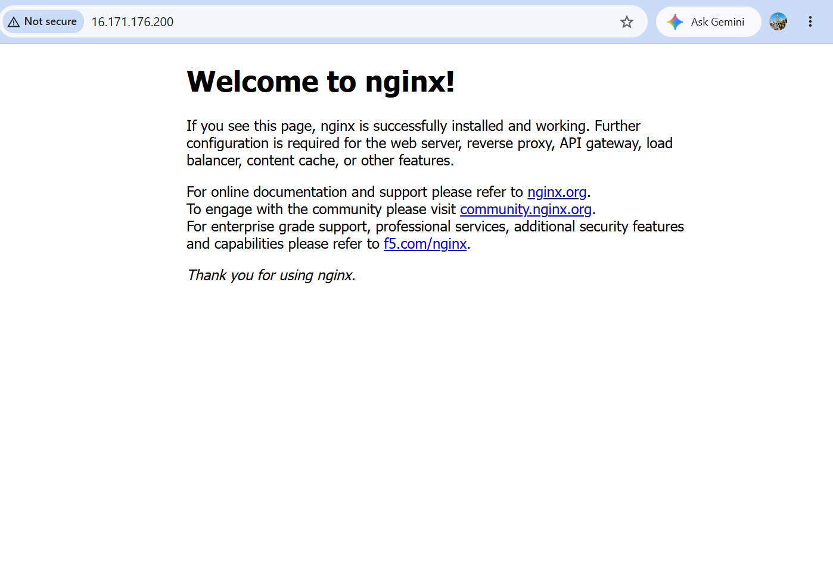

- Create a bash script to install Apache Tomcat on an EC2 server.
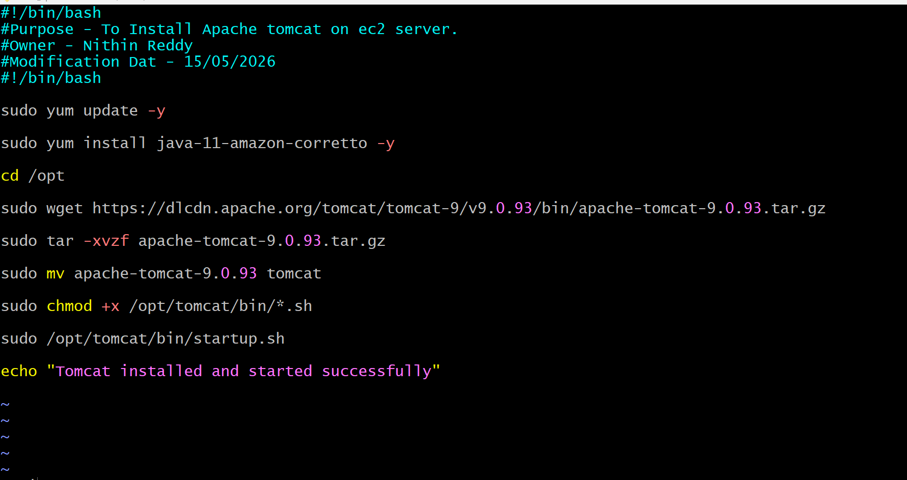
Installed Apache Tomcat on ec2 server
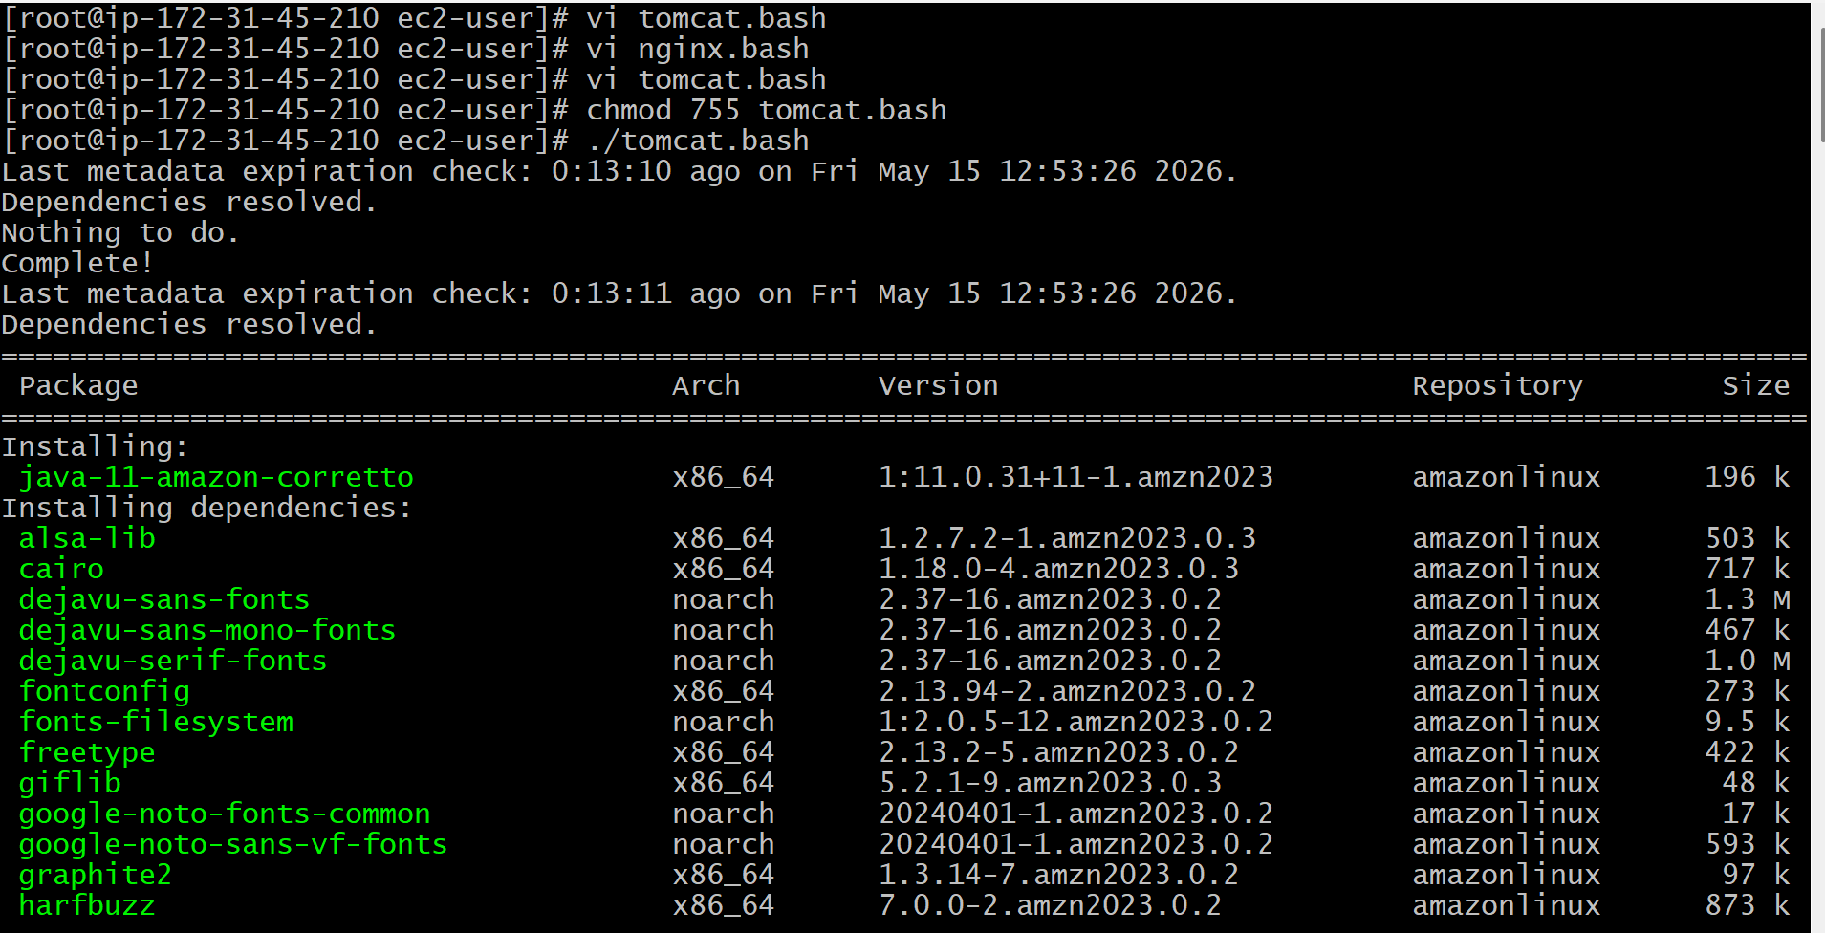
Output:
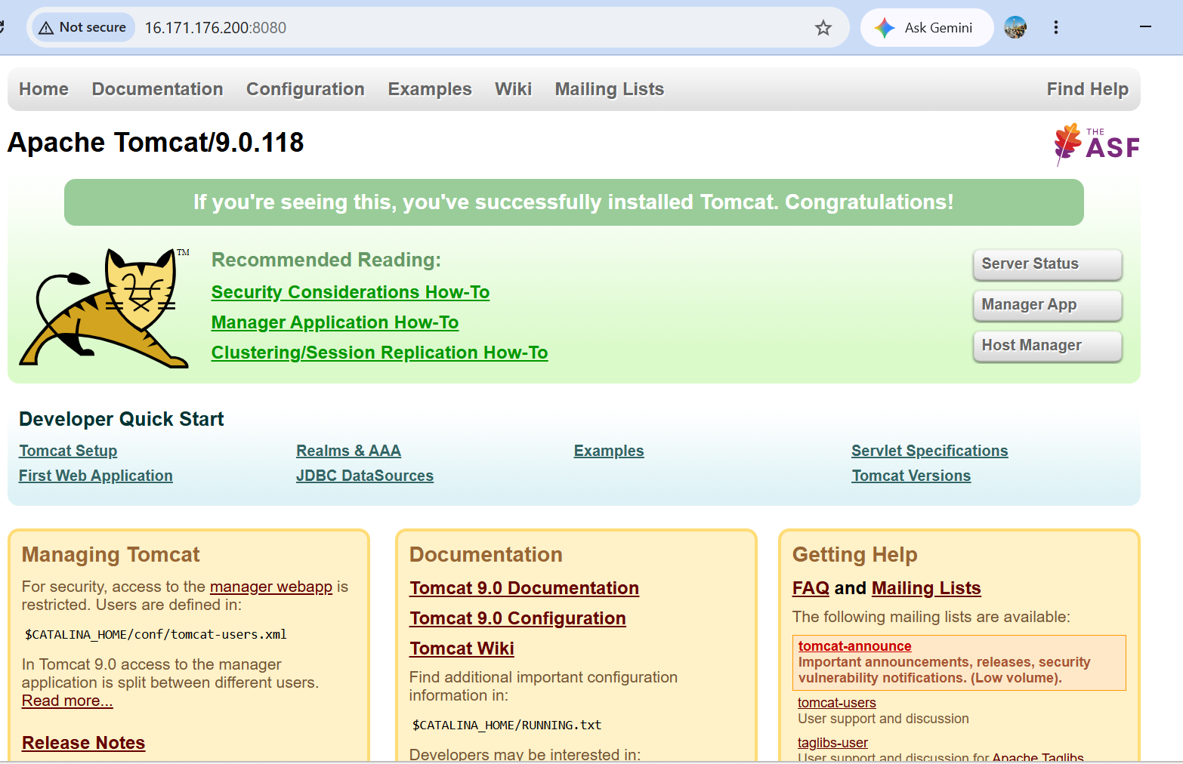

- Create a bash script to check if the Nginx service is running, if not running then script should start the service.
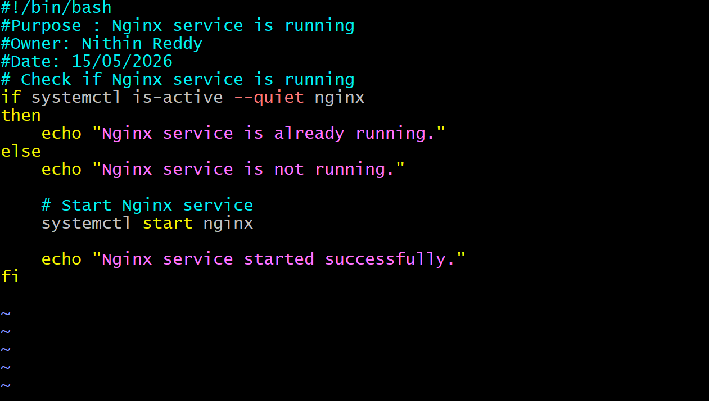
Output:
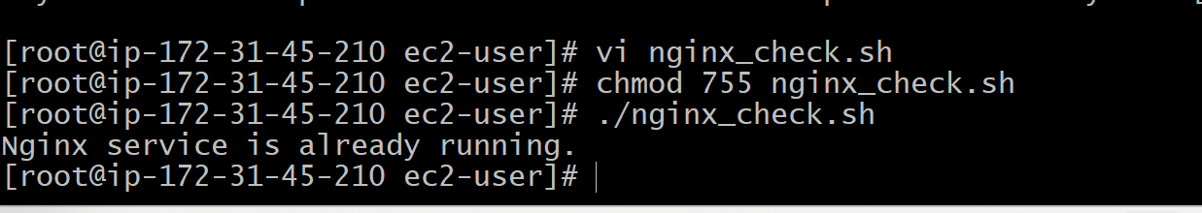
- Create a bash script for a calculator.
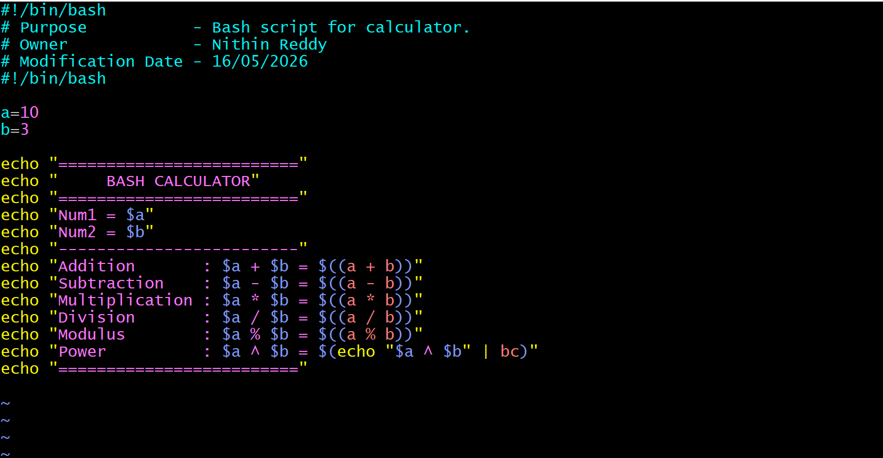
Output:
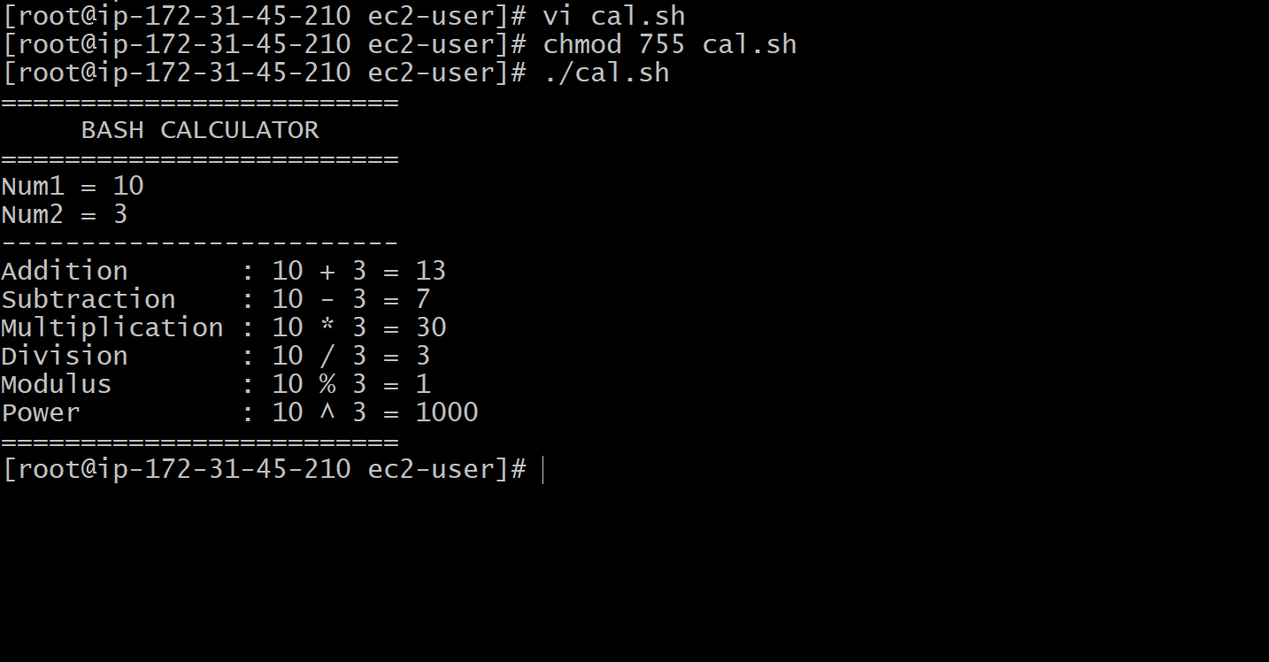
- Create a bash script to check if a directory exists, if not then create a directory.
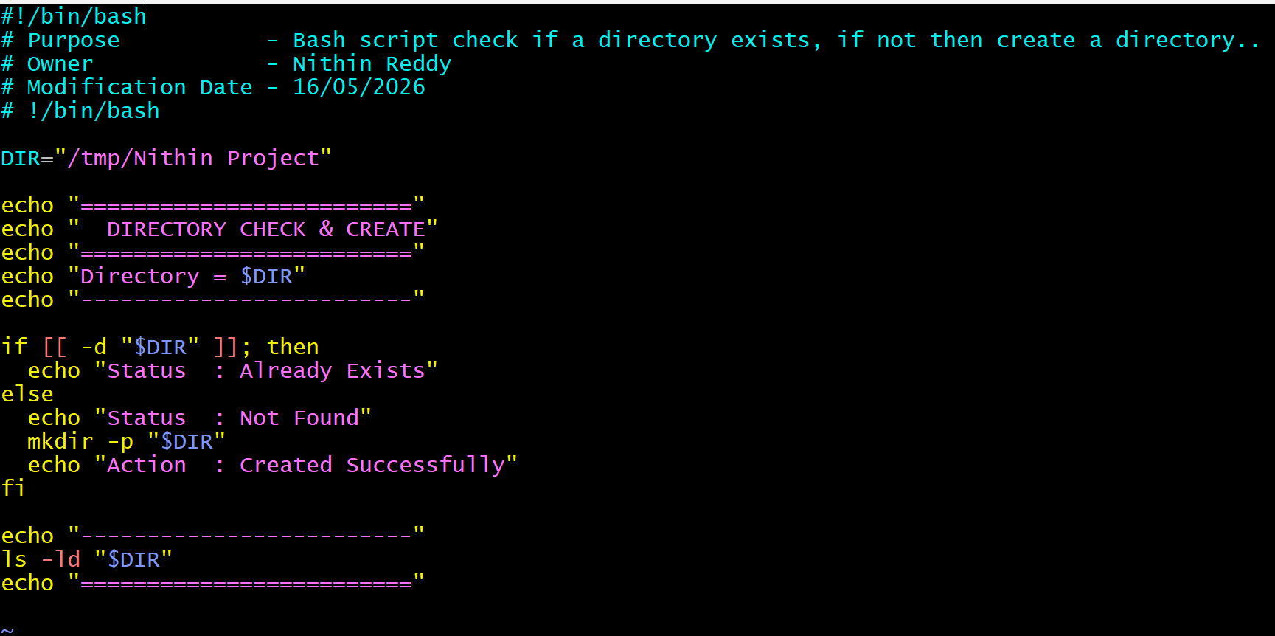
Output:
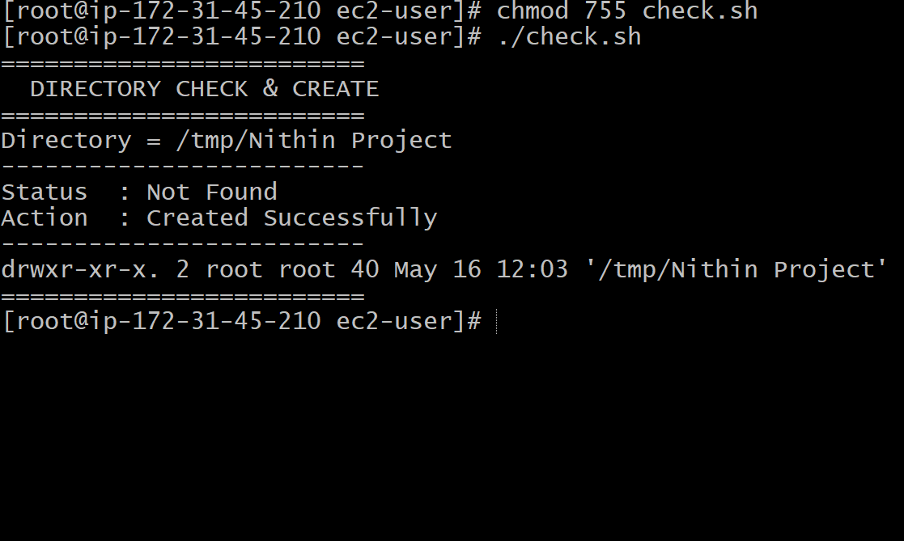
- Create a bash script todelete the last 3 lines of a file.
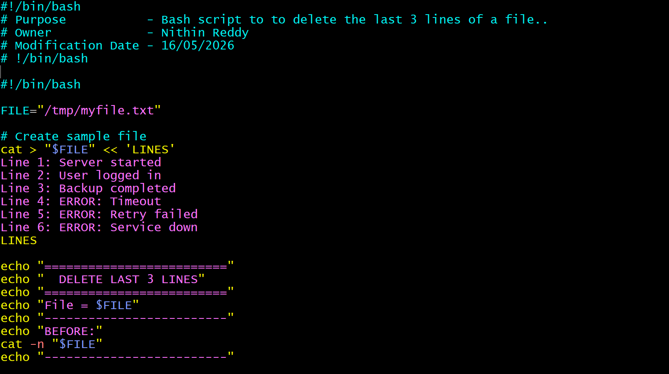
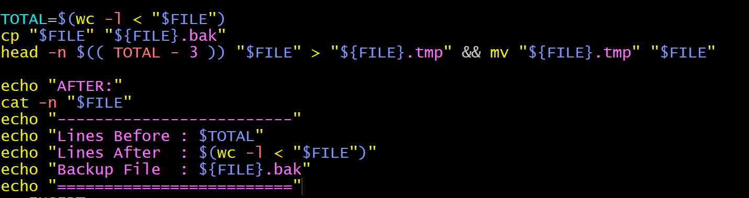
Output:
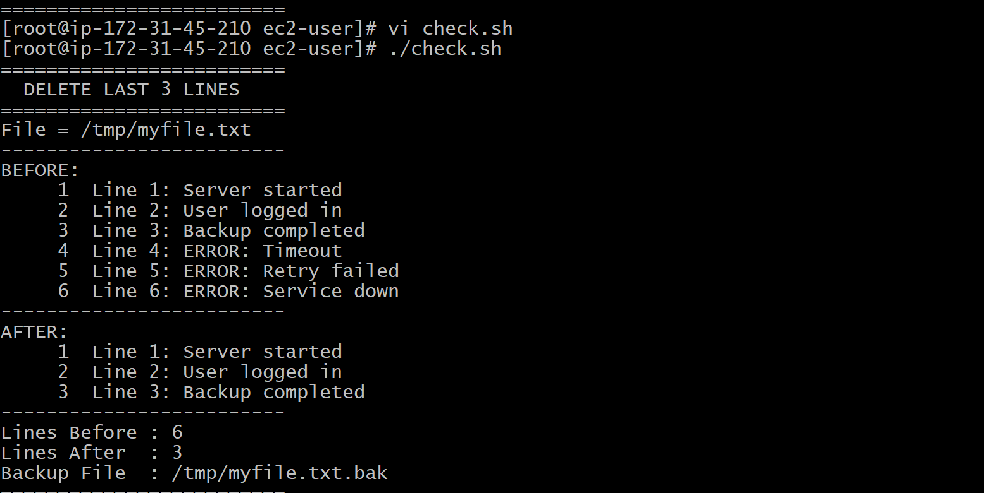
- Bash script to monitor cpu and if it is more than 80% then send email notification.
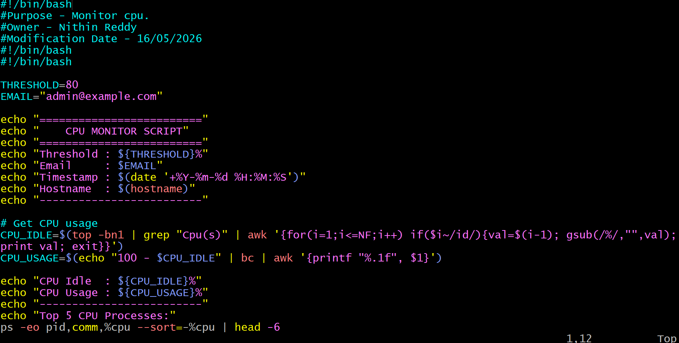
Output:
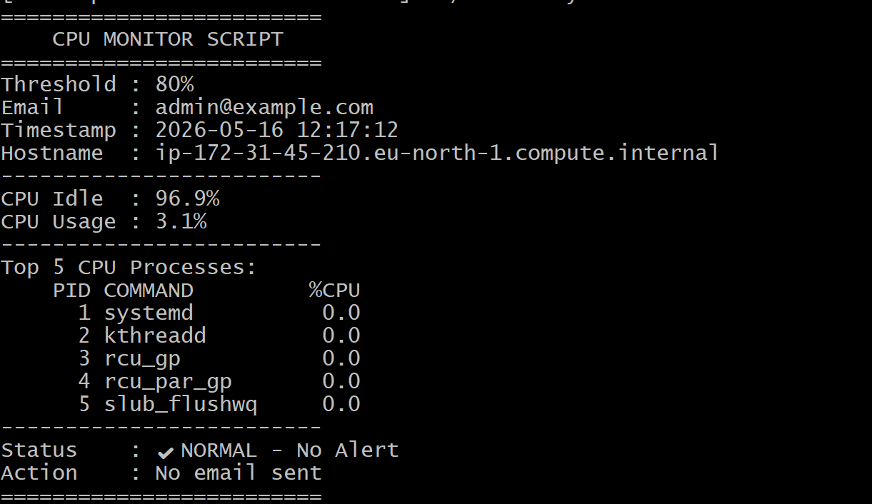
- Bash script to monitor disk space and if it is more than 80% then send email notification.
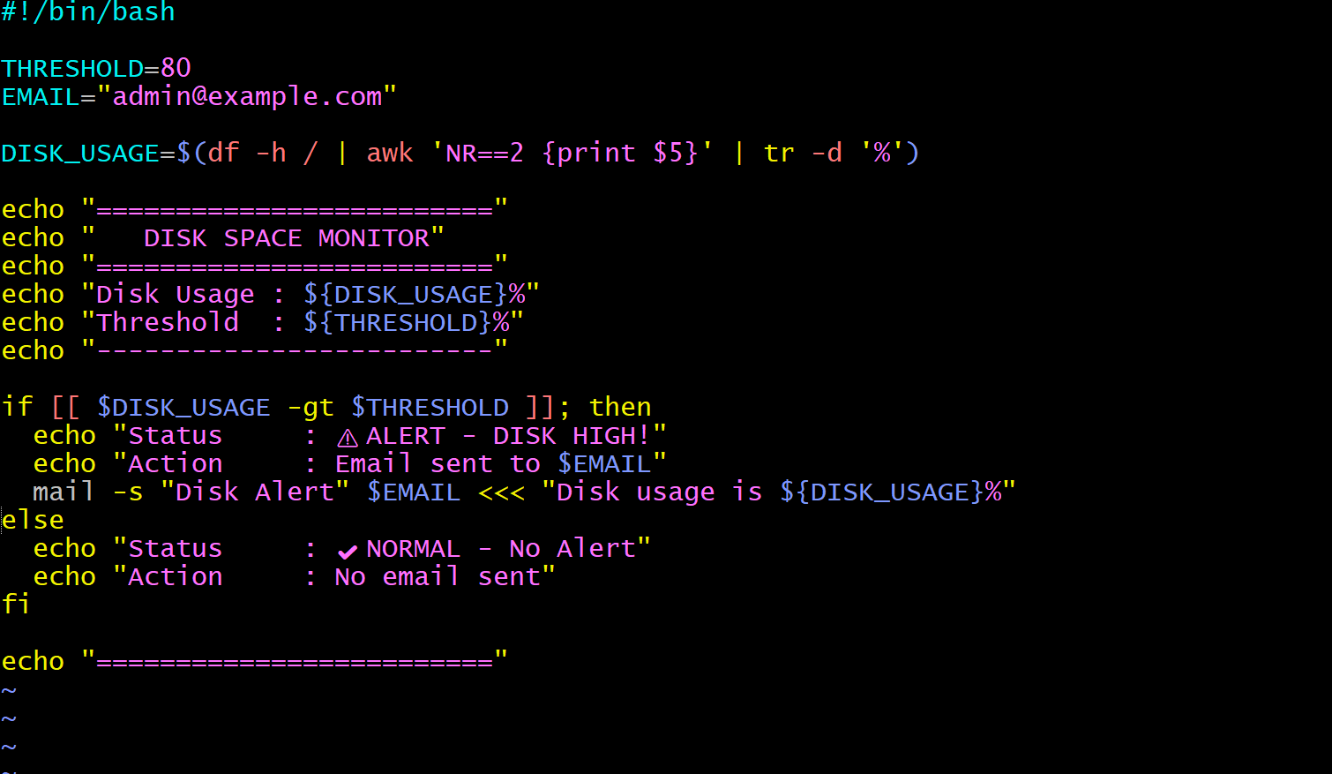
Output:
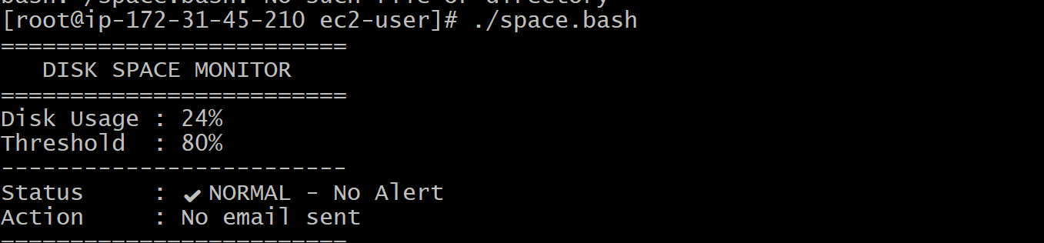
- Bash script to monitor memory and if it is more than 80% then send email notification.
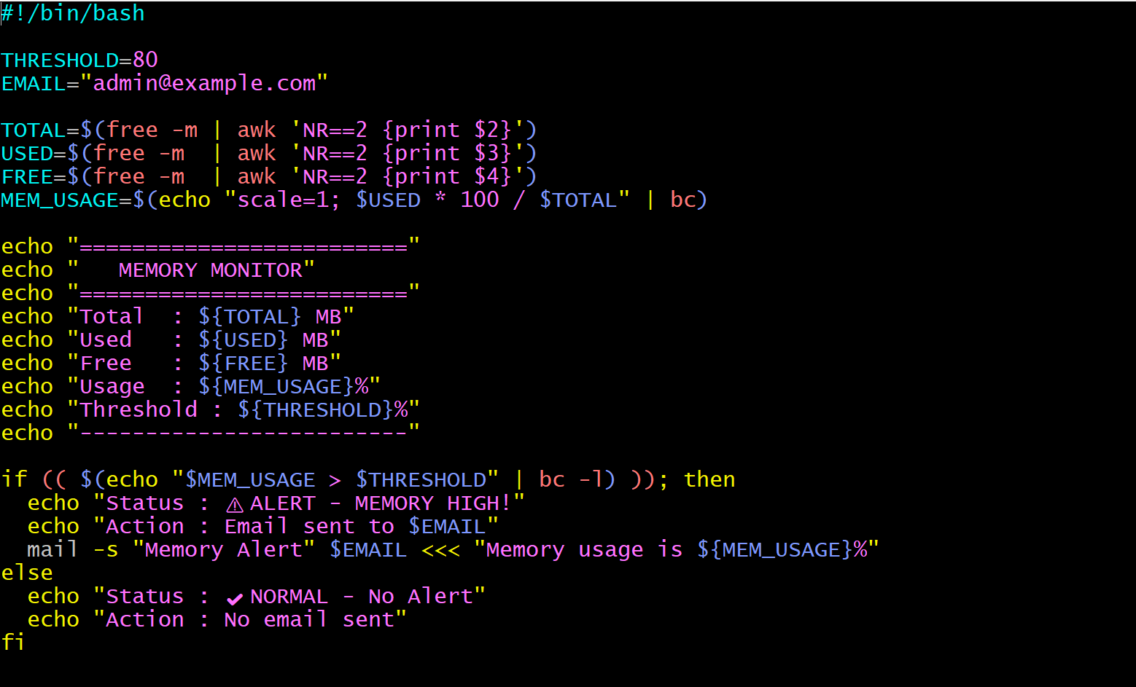
Output:
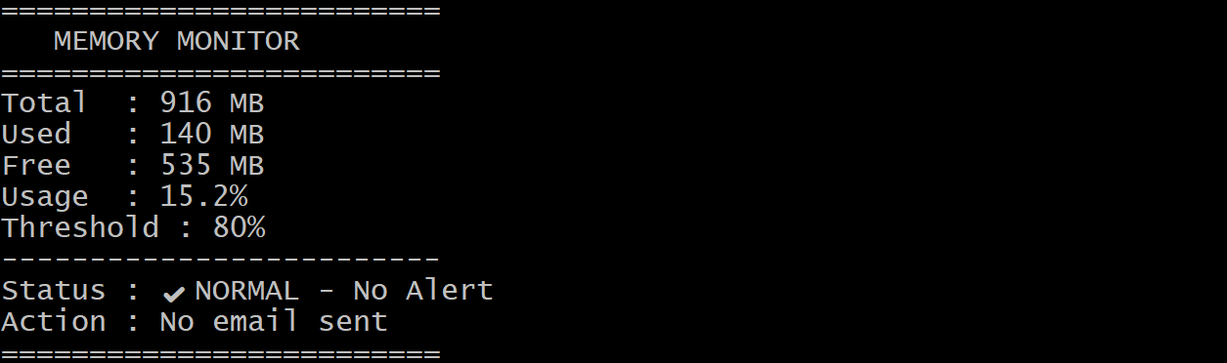
- Crontab
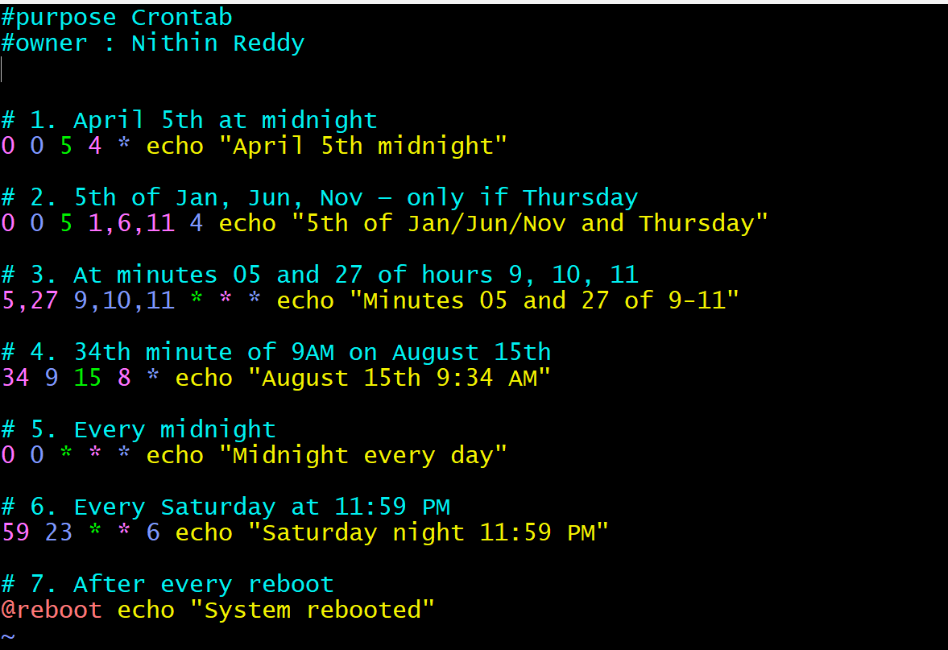
output:
